**Experiment instructions**

In this experiment, you will listen to 10 second long sequences of brief auditory tones. The pitch of these tones can take on many values from high to low, and will vary throughout the tone sequence.

**Trend strength**

Crucially, different tone sequences will exhibit different **trends** or **tendencies** in how the pitches of the tones change over time. In some sequences, there will be **no trend**—this means that

* the pitch of each tone is selected randomly from a bell-shaped distribution by the computer
* the pitch of the upcoming tone does not depend at all upon what tones have been played so far

In other sequences, there will be a **strong trend**—this means that

* over the course of the 10 seconds of the tone sequence, the tone pitches tend to follow long-term trends or overall patterns, such as gradually rising or falling
* the tones you have heard so far give you some information about what tone is likely to come next

In still other sequences, there will be a **medium trend**—this means that

* the sequence of tone pitches will exhibit some trend-like behavior, but not as much as for the sequences with strong trends
* the tones you have heard so far give **some** information about what is likely to come next, but not as much information as you would get from a sequence with a strong trend

Even for the sequences that have the strongest trends in this experiment, the pitch of an upcoming tone cannot be predicted perfectly. However, in sequences with stronger trends, the tones you’ve heard so far are more informative about the **likely** pitch of the upcoming tone.

Intuitively, you can think of “trend strength” as a measure of **tendency** in the sequence. Sequences with higher trend strength have a higher tendency for longer portions of the sequence to exhibit similar overall levels of pitch or changes in pitch over time. It is precisely these longer-term tendencies for trends to occur that make past tones in the sequence informative about upcoming tones.

**Visual examples of trend strength**

To make this more concrete, let’s take a look at some examples of sequences that have different levels of trend strength. You can think of the x-axis as representing time and the y-axis as representing pitch (higher values = higher-pitched tones).

Turn to the next page to see these examples.

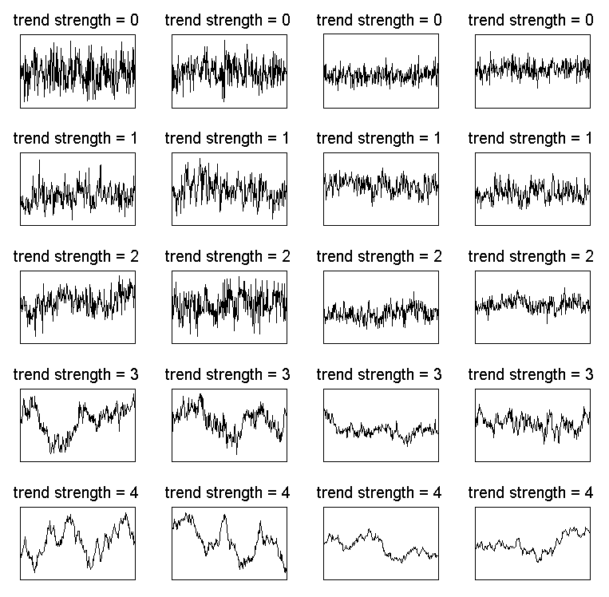

Notice the following about these examples:

* Trend strength can take different values, ranging from no trend at all (top row, trend strength = 0) to strong trend (bottom row, trend strength = 4).
* Trends don’t have to be perfectly predictable patterns—they are just tendencies for large parts of the sequence to take on similar values, or to drift in similar directions.
* “Trend strength” is independent of (1) the overall range spanned by the sequence, and (2) the average size of point-to-point changes in the sequence.
  + Notice that the sequences in the two right columns span smaller ranges, and also have smaller deviations from point to point. Nonetheless, these sequences have the same level of trend strength as the sequences in the two left columns, because they exhibit similar tendencies for longer-term trends to emerge over time.
  + For example, compare the sequences on the top row. In all of these sequences, the pitch at each point in time is unrelated to all the previous pitches. Just because the two sequences on the right span a smaller range of values, it doesn’t mean they exhibit any more of a trend than the two on the left.
  + Now look at the sequences on the bottom row. The two sequences on the right span a smaller range, and also have a smaller “jitter” from point to point. Nonetheless, they exhibit the same degree of trend strength as the two sequences on the left, because they have a similar tendency for trends in the sequence to emerge over relatively long time scales.

**Experimental task**

After listening to each sequence of tones, you will be asked to make three judgments about the sequence.

First question

**How likely was the pitch of the final tone?**

The very last tone in the sequence is selected in a different way than the others. Sometimes the final tone will ‘fit in well’ with the sequence you have heard so far. Other times, it may ‘break the trend’ and not fit in well at all.

You must first tell us how well the final tone fit in with the preceding sequence. You will do this by rating *how likely* it is that a tone sequence like the one you just heard would culminate with the final tone that was actually played.

The rating is done on a scale of 0 – 4, where

0 = the final tone was very unlikely; I was not expecting a tone like that to be played at all; it did not fit in at all with the preceding sequence

4 = the final tone was very likely; it was close to what I was expecting it to be; it fit in well with the preceding sequence

You will enter your rating using the 5 fingers of your LEFT hand to operate the left button box.

|  |  |
| --- | --- |
| LEFT hand finger | final tone likelihood |
| pinky | 0 |
| ring | 1 |
| middle | 2 |
| index | 3 |
| thumb | 4 |

You will be reminded of these response mappings during the experiment.

Second question

**What was the trend strength of the sequence?**

Now you will have to make a judgment about the sequence of tones as a whole (excluding the final tone). What was the trend strength of this sequence? Was there any trend at all? If so, how strong was it?

**Crucially, you must judge the trend strength of the whole series *except for* the very last tone that is played. As explained above, the final tone of the sequence is selected differently from the others and is not a reflection of the underlying trends characterizing the sequence of tones that preceded it.**

The rating of trend strength is done on a scale of 0 – 4, where

0 = no trend at all; the pitch of each tone was completely independent from the ones that had come before

4 = strong trend; large portions of the sequence exhibited similar pitches or tendencies to change in pitch

The values of trend strength from 0 to 4 that you will use to categorize each auditory sequence correspond to the values of trend strength from 0 to 4 shown in the visual examples above. You may want to study these visual examples again to get an idea of what is meant by each level of trend strength.

Each tone sequence you will hear has a ‘true’ trend strength ranging from 0 to 4, where again these values for trend strength are illustrated in the examples above. Thus, your rating for the trend strength of a given sequence can be correct or incorrect. You will be informed whether your trend strength rating was correct or incorrect at the end of each trial.

You will enter your rating using the 5 fingers of your RIGHT hand to operate the right button box.

|  |  |
| --- | --- |
| RIGHT hand finger | trend strength |
| thumb | 0 |
| index | 1 |
| middle | 2 |
| ring | 3 |
| pinky | 4 |

You will be reminded of these response mappings during the experiment.

Third question

**How confident are you about the trend strength rating you just made?**

Sometimes you may be pretty confident that your trend strength rating was correct. At other times, you may feel like you had no idea and you just had to make a wild guess that would only be correct as a result of random chance. With the third and final question, you will indicate this confidence in your trend strength rating.

The rating of confidence is done on a scale of 0 – 4, where

0 = no confidence at all; the trend strength rating was a pure guess, a total shot in the dark

4 = high level of confidence; you’re pretty sure that your trend strength rating was correct

Note that you don’t have to reserve a confidence rating of 4 for being 100% sure that you were correct about the trend strength. The highest level of confidence just means that, in the context of this experiment, this is one of the trials where you feel most confident about your trend strength rating. Because the task is somewhat difficult, you may never feel 100% sure about your response; that’s OK. Use the confidence scale to reflect gradations in the range of confidence you feel throughout the experiment, while also being sure to use the whole confidence scale.

You will enter your confidence rating using the 5 fingers of your LEFT hand to operate the left button box.

|  |  |
| --- | --- |
| LEFT hand finger | confidence |
| pinky | 0 |
| ring | 1 |
| middle | 2 |
| index | 3 |
| thumb | 4 |

You will be reminded of these response mappings during the experiment.

Response times

For each of the three questions, you will have up to 5 seconds to answer. If you don’t answer in time, a ‘Too slow!’ message will appear on the screen and the next trial will begin.

We can’t use trials where you don’t answer all three questions within the time limit, so please be mindful of entering all three responses within a reasonable amount of time.

If you are completely unsure of what to respond, it is OK to guess. It is much better to guess than to fail to enter any response at all. If you do have to make a guess, try to make sure your guess is chosen randomly. That is, don’t employ a rigid strategy for guessing, such as “if I’m not sure what the trend strength was, I will always press my index finger.” Instead, your strategy for guessing should be more like “if I’m not sure what the trend strength was, I will just enter my best guess, and I have no best guess at all, I will just push a random button.”

Performance feedback, practice, and questions

After you have entered your three responses, you will see a message on the screen letting you know how close your trend strength rating was to the true trend strength. This will help you get a grasp on how to answer the trend strength question. It may also help you get a handle on the other two questions. If you get better at identifying trend strength, you may be able to use this information to help you assess how likely the final tone in the sequence was. Additionally, the feedback about your trend strength rating may help you get a better sense of when you should be confident and unconfident in your trend strength ratings.

You will also get a chance to practice before beginning the main experiment. This will give you a feel for how to answer the three questions for each tone sequence, and how to enter your responses using the button boxes.

If anything is unclear, please do not hesitate to ask the experimenter. This may seem like a lot to digest, but you will get the hang of things quickly once we start doing some practice trials.

In the MEG scanner

If you will be performing this task in the MEG scanner, you will alternate between break periods where you can rest, and active periods where you are doing the task and the scanner is recording. During the active periods, it is important to be mindful of the following:

* Please move as little as possible.
* Please do not close your eyes. (It is OK to blink if you need to, but try to minimize blinks as well.)

In the break periods it is OK to close your eyes, but you should still try to minimize movement if possible.